25.74: Initially:
Finally:
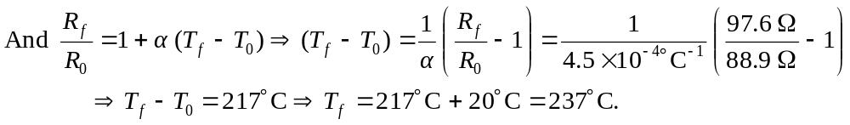
b) (i)
(ii) 